(****) Define aggregation and composition. How are they different?
Inheritance : (is a relation ).
Hibernate : (has – A ) :- one to one , one to many , many to many..
Association (HAS-A):
Aggregation and composition are nothing but types of association in java where association define the relationship between two classes.
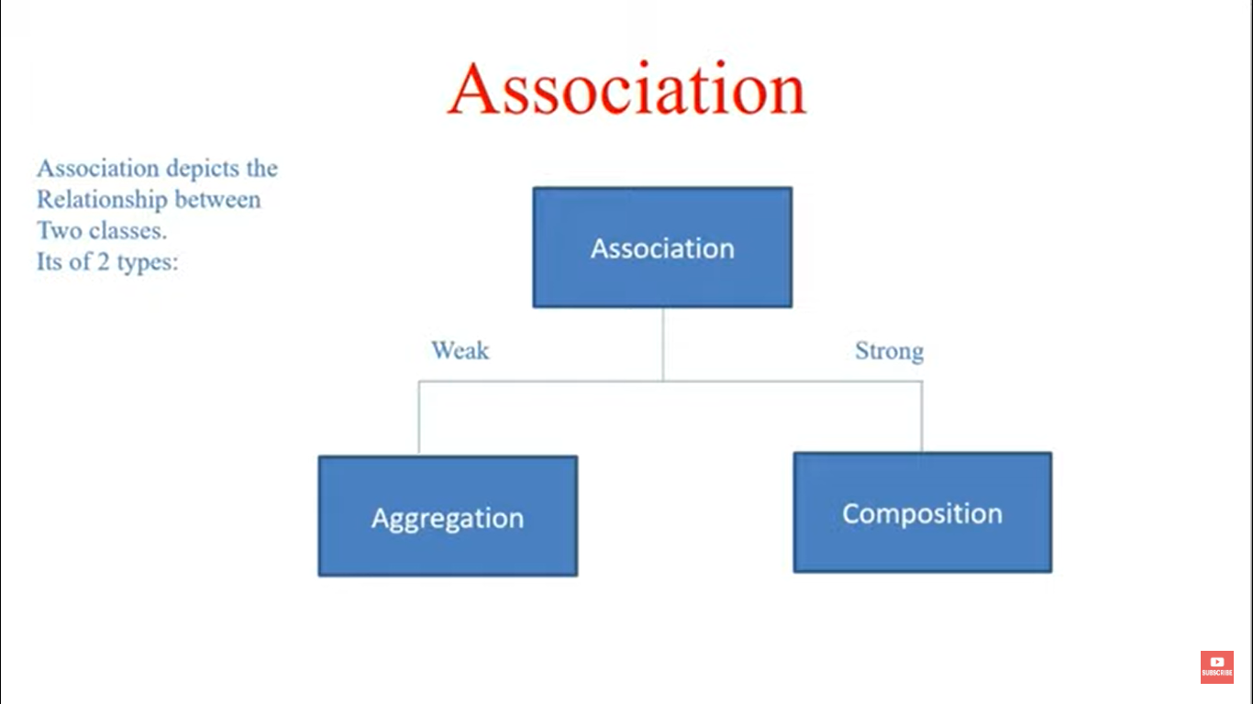
Aggregation : both objects can exist independently .
Real life ex- A "Team" class that contains "Player" objects. Players can exist independently of the Team.
Composition : both objects can’t exist independently . one object can’t exist without owner object.
Real time ex - A "Car" class that contains an "Engine" object. The Engine cannot exist without the Car.

(***) WHAT IS COVARIANT RETURN TYPE IN JAVA ?
The return type of child should be either the same of that parent class or it should be the sub class of the return type of parent class.
Parent : public Object m1(){};
Child : public String m1 () { return “hi”};

(***) CAN YOU EXPLAIN METHOD OVERLOADING WITH TYPE PROMOTION ?
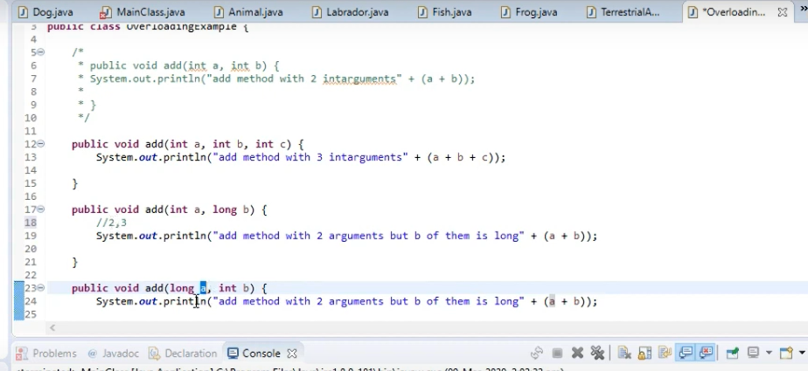
(***) Can we implement dynamic polymorphism with instance variables or data members?
No , because when we do Parent p = new Child(); sop(p.color ); ans=> parent color.

